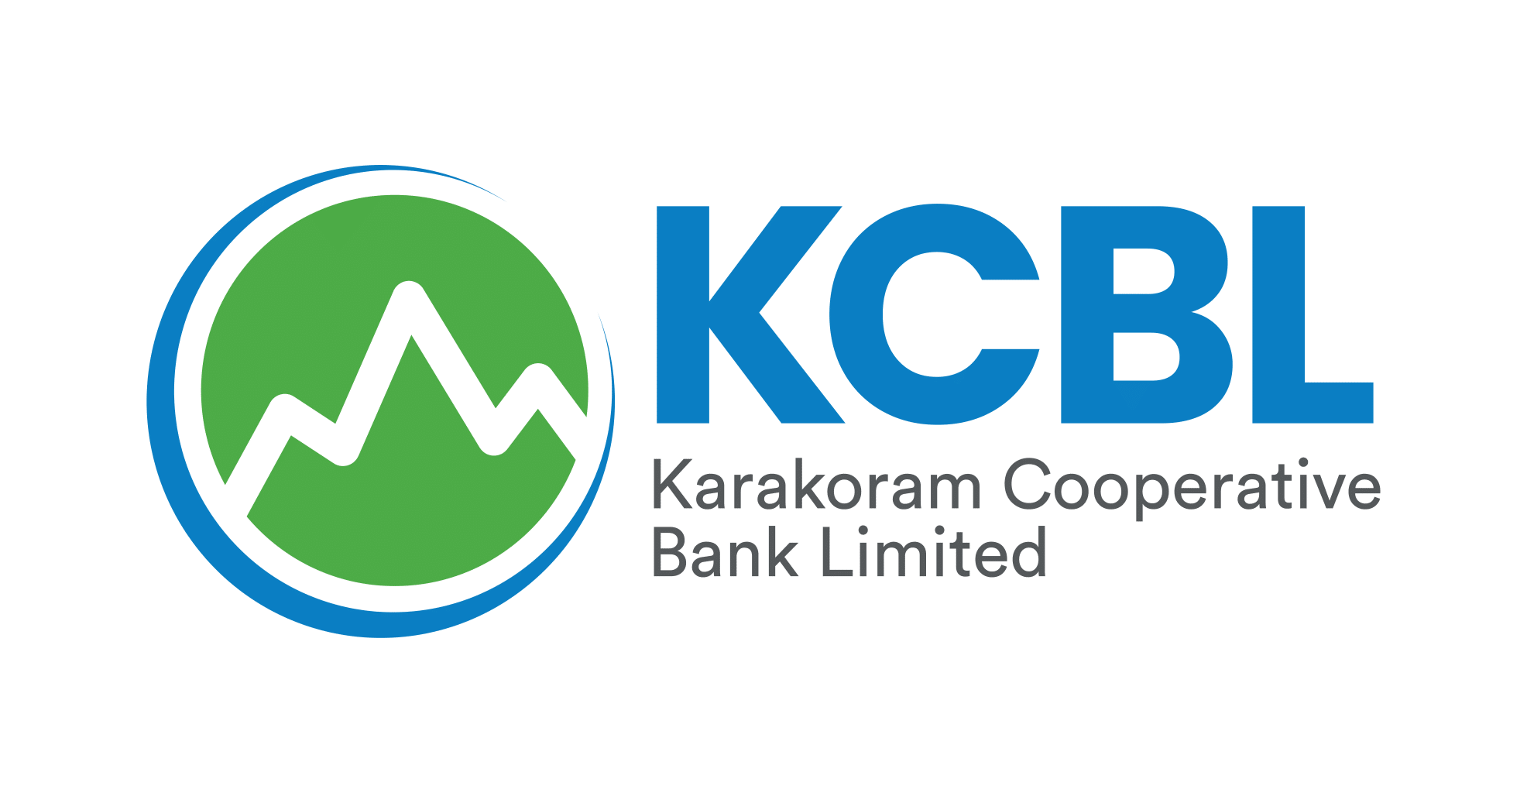

CORRIGENDUM
(Extension of EOI Submission Deadline)
With reference to the Invitation for Expressions of Interest (EOI) from eligible and experienced firms for procurement, up-gradation, implementation, customization, data migration, and support of a Core Banking System (CBS), the last date for submission of EOI has been extended up to 27/01/2026, in accordance with the Public Procurement Rules, 2004.
All other terms and conditions of original tender notice remain unchanged.

Senior Manager Administration
Karakoram Cooperative Bank Ltd
Head Office, Gilgit
Phone: 05811457523

